LAB-10 INTRODUCTION TO BISON

Name: Ketan Goud
Reg No: 220905260
Section: D2
Roll No: 39
Write a bison program,
1. To check a valid declaration statement.
//q1.y
%{
#include <stdio.h>
#include <stdlib.h>
int yylex();
int yyerror(char *msg);
%}

%token INT FLOAT CHAR ID NUM SEMI COMMA ASSIGN

%%
decl_stmt: type_specifier decl_list SEMI
{ printf("Valid Declaration\n"); exit(0); }
;

type_specifier: INT
| FLOAT
| CHAR
;

decl_list: decl
| decl_list COMMA decl
;

decl: ID
| ID ASSIGN NUM
;
%%

int yyerror(char *msg)
{
printf("Invalid Declaration\n");
exit(0);
}

int main(void)
{
printf("Enter a declaration statement:\n");
yyparse();
return 0;
}

//q1.l
%{
#include "q1.tab.h"
%}

%%
"int" { return INT; }
"float" { return FLOAT; }
"char" { return CHAR; }
[0-9]+ { return NUM; }
[a-zA-Z_][a-zA-Z0-9_]* { return ID; }
";" { return SEMI; }
"," { return COMMA; }
"=" { return ASSIGN; }
[ \t\n]+ { /* Skip whitespace */ }
. { return yytext[0]; }
%%

int yywrap() { return 1; }

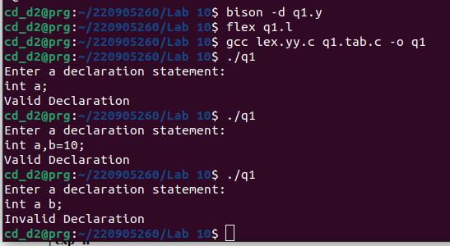
2. To check a valid decision making statements.
//q2.y
%{
#include <stdio.h>
#include <stdlib.h>
int yylex();
int yyerror(char *msg);
%}

%token IF ELSE LPAREN RPAREN LBRACE RBRACE ID NUM GT ASSIGN SEMI
%left GT

%%
program:
stmt { printf("Valid decision statement\n"); exit(0); }
;
stmt:
matched_stmt
| unmatched_stmt
;
matched_stmt:
IF LPAREN expr RPAREN matched_stmt ELSE matched_stmt
| other_stmt
;
unmatched_stmt:
IF LPAREN expr RPAREN stmt
;
other_stmt:
block
| assign_stmt
;
block:
LBRACE stmt_list RBRACE
;
stmt_list:

| stmt_list stmt
;
assign_stmt:
ID ASSIGN expr SEMI
;
expr:
expr GT expr
| ID
| NUM
;
%%

int yyerror(char *msg)
{
printf("Invalid decision statement\n");
exit(0);
}

int main(void)
{
printf("Enter a decision making statement:\n");
yyparse();
return 0;
}

//q2.l
%{
#include "q2.tab.h"
%}

%%
"if" { return IF; }
"else" { return ELSE; }
"(" { return LPAREN; }
")" { return RPAREN; }
"{" { return LBRACE; }
"}" { return RBRACE; }
";" { return SEMI; }
">" { return GT; }
"=" { return ASSIGN; }
[0-9]+ { return NUM; }
[a-zA-Z][a-zA-Z0-9]* { return ID; }
[ \t\n]+ { /* Skip whitespace */ }
. { return yytext[0]; }
%%

int yywrap(void) { return 1; }

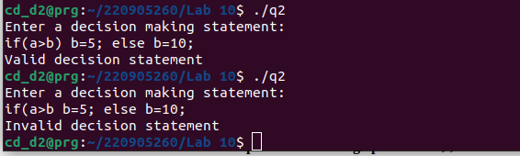
3. To evaluate an arithmetic expression involving operations +,-,* and /.
//q3.y
%{
#include <stdio.h>
#include <stdlib.h>

int yylex();
void yyerror(const char *s);

%}

%token NUM
%left '+' '-'
%left '*' '/'
%left NEG // For unary minus
%left '^'

%%

input:
| input line
;

line:
'\n' { /* Empty line */ }
| expr '\n' { printf("Result: %d\n", $1); }
;

expr:
NUM { $$ = $1; }
| expr '+' expr { $$ = $1 + $3; }
| expr '-' expr { $$ = $1 - $3; }
| expr '*' expr { $$ = $1 * $3; }
| expr '/' expr { if ($3 == 0) { yyerror("Division by zero!"); } else { $$ = $1 / $3; } }
| '(' expr ')' { $$ = $2; }
| '-' expr %prec NEG { $$ = -$2; }
;

%%

void yyerror(const char *s) {
fprintf(stderr, "Error: %s\n", s);
}

int main() {
printf("Enter an arithmetic expression: ");
yyparse();
return 0;
}

//q3.l
%{
#include "q3.tab.h"
%}

%%

[0-9]+ { yylval = atoi(yytext); return NUM; }
[ \t] { /* Skip whitespace */ }
[\n] { return '\n'; }
"+" { return '+'; }
"-" { return '-'; }
"*" { return '*'; }
"/" { return '/'; }
"(" { return '('; }
")" { return ')'; }

. { return yytext[0]; }

%%

int yywrap() {
return 1;
}
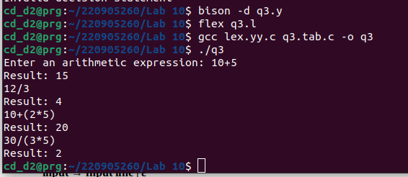
4. To validate a simple calculator using postfix notation. The grammar rules are as follows –
input → input line | ε
line → ‘\n’ | exp ‘\n’
exp → num | exp exp ‘+’
| exp exp ‘-‘
| exp exp ‘*’
| exp exp ‘/’
| exp exp ‘^’
| exp ‘n’

%{
#include <stdio.h>
#include <stdlib.h>
int yylex();
int yyerror(char *msg);
%}

%token NUMBER

%%
input:
/* empty */
| input line
;
line:
'\n'
| exp '\n'
;
exp:
NUMBER
| exp exp '+'
| exp exp '-'
| exp exp '*'
| exp exp '/'
| exp exp '^'
| exp 'n'
;
%%

int yyerror(char *msg)
{
printf("Invalid postfix expression\n");
exit(1);
}

int main(void)
{
printf("Enter postfix expression:\n");
yyparse();
printf("Valid postfix expression\n");
return 0;
}

//q4.l
%{
#include "q4.tab.h"
#include <stdlib.h>
%}

%%
[0-9]+ { yylval = atoi(yytext); return NUMBER; }
\n { return '\n'; }
"n" { return 'n'; }
"+" { return '+'; }
"-" { return '-'; }
"*" { return '*'; }
"/" { return '/'; }
"^" { return '^'; }
[ \t]+ { /* skip whitespace */ }
. { return yytext[0]; }
%%

int yywrap(void) { return 1; }

